Below are transactions produced into Kafka consumer for topic “queueing.transactions”

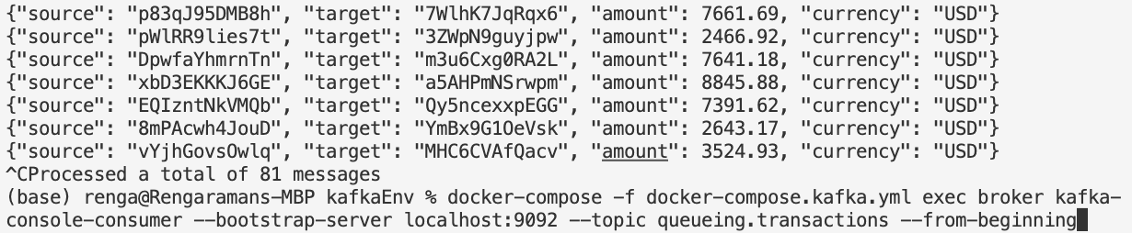

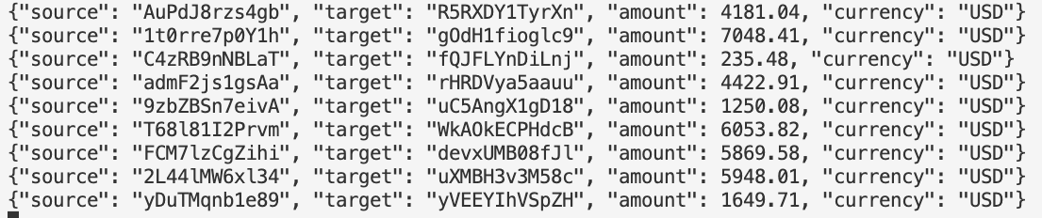

Below are transactions produced into Kafka consumer for topic “streaming.transactions.legit”

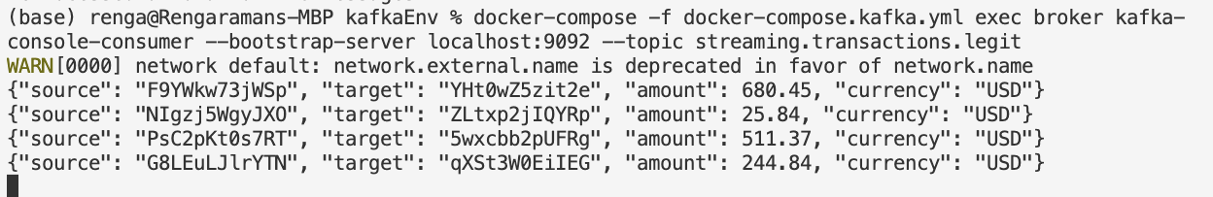

Below are transactions produced into Kafka consumer for topic “streaming.transactions.fraud”

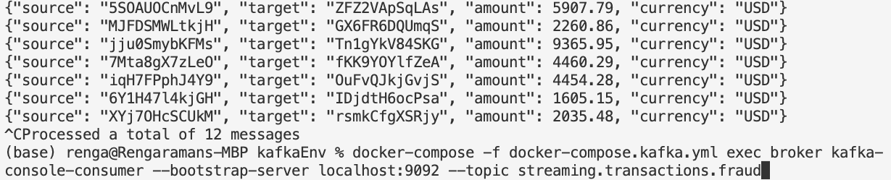



Live transactions generated and consumed screenshot

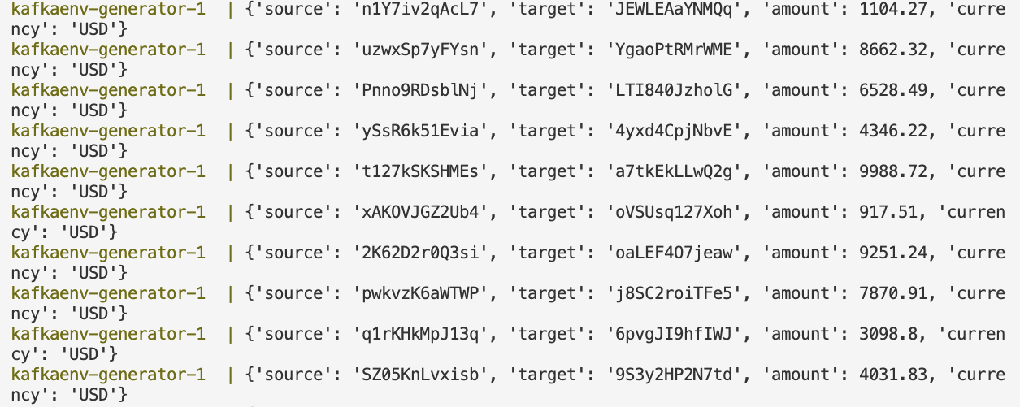

Write Fraudulent transactions to file until it reaches 10000 bytes and then send email to inform about those transactions.

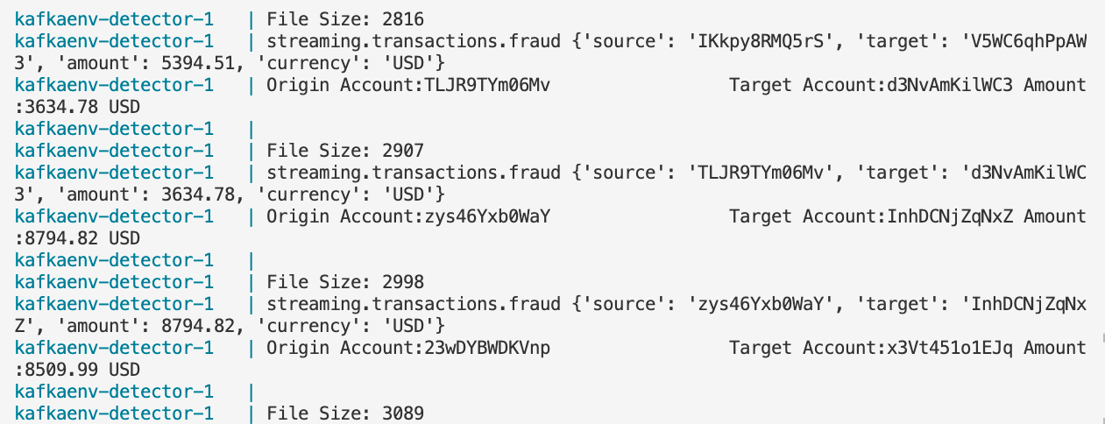

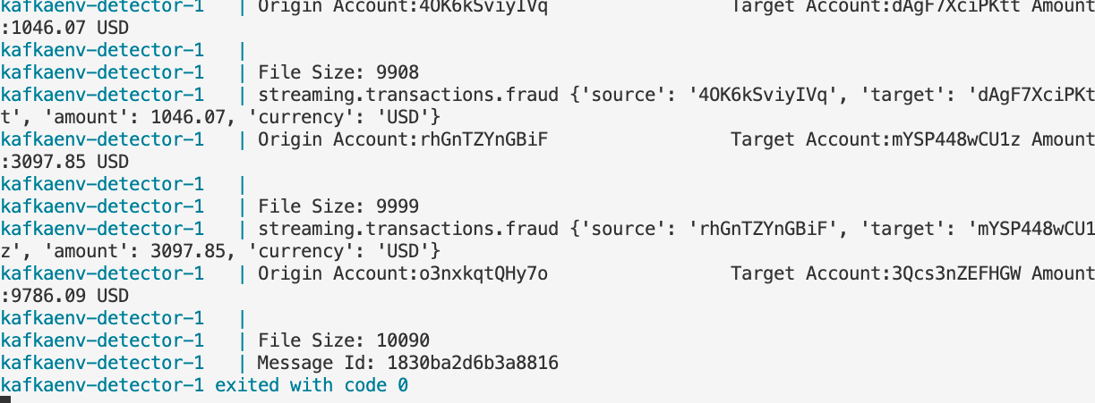

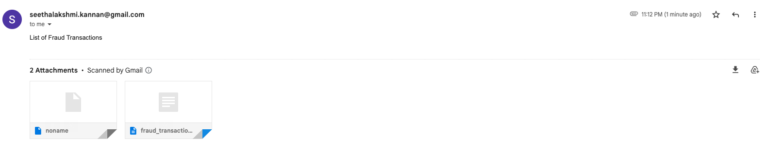

fraud_transactions.txt separately attached in github